Patterns of Settlement in early Colonial Jamestown
From “Exploring Land, Settling Frontiers.”

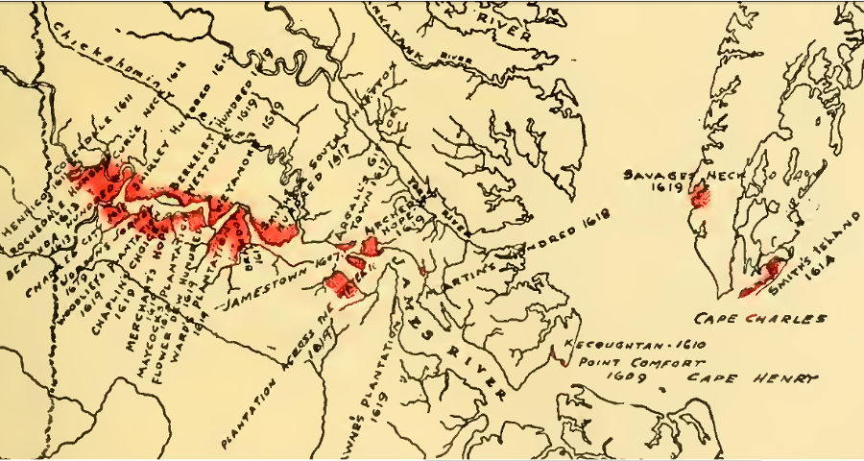
Settlement in Jamestown, 1619

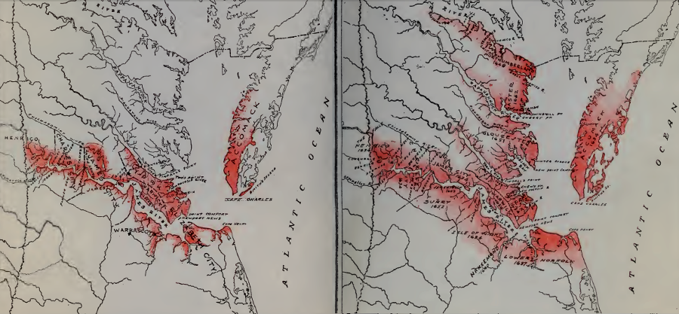
Settlement in Jamestown, 1634-52
Between 1634-1652, English settlements expanded north to the Potomac River
Source: Nell Marion Nugent, Cavaliers and Pioneers; Abstracts of Virginia Land Patents and Grants, 1623-1800

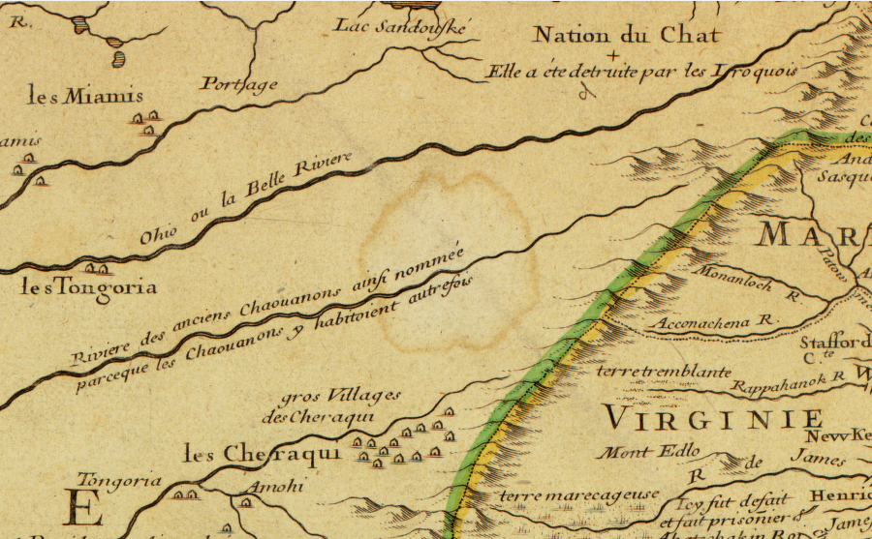
Westward Expansion in Virginia to 1718

In 1718, the Blue Ridge separated settlers on the east from various Native American groups on the west, including the Cherokee (Cheraqui), Yuchi (Tongoria), Miami, and Erie (Nation de Chat)
Map Source: Library of Congress, Carte de la Louisiane et du cours du Mississippi ... (by Guillaume De L'Isle, 1718)

